**DEPARTMENT OF COMPUTER SCIENCE AND ENGINEERING**

# Computer Programming (CS134P)

B. Tech Degree- CHEMISTRY CYCLE

**School of Engineering and Technology, CHRIST (Deemed to be University), Kumbalagodu, Bengaluru-560 074**

December 2021

***Certificate***

*This is to certify that has successfully completed*

*the record work for Computer Programming –CS134P in partial fulfillment for the award of Bachelor of Technology in during the year 2021-2022.*

## Dr. K. Balachandran

**HEAD OF DEPARTMENT FACULTY- IN CHARGE**

**EXAMINER 1:**

**EXAMINER 2:**

Name :

Register No. : Examination Center : Date of Examination :

**INDEX**

|  |  |  |  |  |  |
| --- | --- | --- | --- | --- | --- |
| **Exp. No** | **Date** | **Experiment Name** | **Page No** | **Marks** | **Signature** |
| 1 |  |  |  |  |  |
|  |  |  |  |  |  |
|  |  |  |  |  |  |
|  |  |  |  |  |  |
|  |  |  |  |  |  |
|  |  |  |  |  |  |
|  |  |  |  |  |  |
|  |  |  |  |  |  |
|  |  |  |  |  |  |
|  |  |  |  |  |  |
|  |  |  |  |  |  |
|  |  |  |  |  |  |

**Ex. No: 8b Date: 29-11-2021**

**RETURNING AN ARRAY AS ARGUMENT**

**PROBLEM GIVEN:**

Write a C program to implement the following:

1. Define a function get_details. Get two arrays from the users - The first one contains the roll number and the second array contains their corresponding marks.

2. In the same function, Find the marks that are above 70. return the corresponding register numbers from array1 using pointers to main.

3. In main(), arrange the register numbers in ascending order.

**ALGORITHM:**

Step 1: Start

Step 2: Declare necessary variables and function get_details.

Step 3: Read number of elements from user to be entered in arrays for roll number and marks.

Step 4: Check if the marks are above 70. Those roll numbers having marks above 70 are returned to main function using pointers.

Step 5: In main function, arrange the roll numbers in ascending order.

Step 6: Print all necessary outputs

**FLOWCHART:**

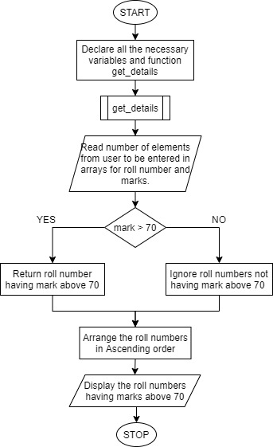

**PROGRAM:**

#include <stdio.h>

typedef int* pnt;

int len;

int roll[50];

int mark[50];

int roll_70[50];

int mark_70[50];

int ind_70 = 0;

pnt n = &len;

pnt r = &roll;

pnt m = &mark;

pnt r_70 = &roll_70;

pnt m_70 = &mark_70;

void get_details()

{

printf("Enter the number of roll numbers to be entered:\n");

scanf("%d", n);

printf("Enter the roll numbers with their respective marks:\n");

for (int i = 0; i < *n; i++)

{

scanf("%d %d", r++, m++);

if (mark[i] >= 70)

{

roll_70[ind_70] = roll[i];

mark_70[ind_70] = mark[i];

ind_70++;

}

}

}

void main()

{

get_details();

int temp;

for (int i = 0; i < ind_70; i++)

{

for (int j = 0; j < ind_70 - 1; j++)

{

if (roll_70[j] > roll_70[j + 1])

{

temp = roll_70[j];

roll_70[j] = roll_70[j + 1];

roll_70[j + 1] = temp;

temp = mark_70[j];

mark_70[j] = mark_70[j + 1];

mark_70[j + 1] = temp;

}

}

}

for (int i = 0; i < ind_70; i++)

printf("Roll number: %d\tMarks: %d\n", roll_70[i], mark_70[i]);

}

**OUTPUT:**

## 